Name: Isep Lutpi Nur

NPM: 2113191079

Lab – Locate Your Personal Data

1. Objectives

Find your personal data online and on your computing devices.

1. Background / Scenario

If you search your name online, there is a good chance that you will find some information about yourself in the result. Some of the results may be private information, such as your birthday, that you may want to protect. Some of this information may also be stored on your computing devices.

In this lab, you will use a search engine to search your name to find information about you. You will then use Windows Powershell to search for any personally identifiable information in text files on your Windows PC.

1. Required Resources

* Windows PC with Internet access
  1. Personal Data Online

In step 1, you will search for your name online.

* + 1. Search for your name using your favorite search engine. It may be helpful to surround your name with quotation marks, for example “John Doe”.

What did you find about you?

**Answer:**

After I searched my name "Isep Lutpi Nur" Using the Google search engine I found some information about myself. First Start from linkedin, facebook, Github, blogs and others.

* + 1. If there are links to your social media profile, navigate to them to view the content as a visitor without logging into any sites.

What information is displayed about you on these sites?

**Answer:**

I open social media twitter without logging in with the site and go to my profile account, there is some information that can be obtained including. address, some photos of me and the post

* + 1. If you are sharing too much, you can change the privacy settings. Here are some ways to get to the security / privacy settings on some of the popular social media sites:

**Facebook**: Click https://scontent-sjc2-1.xx.fbcdn.net/hphotos-xaf1/t39.2365-6/851557_364200877036449_574807949_n.gif, select **Settings**.

**Linked In**: Click your name and select **Settings**.

**Google**: Click your picture or avatar, select **My Accounts**

**Pinterest**: Click **Help Center**, select **My account**

* 1. Personal Data on Your Computing Devices

Besides your online information, some of your personal information may be stored on your computing devices. In this step, you will create a few text files and use Microsoft PowerShell to search for specific information in the text files. The username User1 is used throughout this step in place of your username.

* + 1. Navigate to your Documents directory. Create a directory name **PersonalData**.
    2. Create a few text files using **Notepad** containing the following text and save them in your newly created **PersonalData** directory using the indicated filenames.

|  |  |
| --- | --- |
| Filename | Content |
| **File1.txt** | My Social Security Number is: 111-11-1111 |
| **File2.txt** | My Credit Card Number: 5555-5555-5555-5555  My Social Security Number: 123-45-6789 |
| **File3.txt** | My Credit Card Number:  9999 9999 9999 9999  My ID Number:  987654321 |

* + 1. Click **Start**. Search for **powershell**.

**Note**: If Microsoft PowerShell is not available, you can download it from Microsoft. Please review the installation instructions and system requirement from Microsoft to determine the version to download for your Microsoft operating system.

Vista: <https://www.microsoft.com/en-us/download/details.aspx?id=9864>

Windows 7 and 8: <https://www.microsoft.com/en-us/download/details.aspx?id=48729>

* + 1. Navigate to the **PersonalData** directory by typing the following command at the PowerShell prompt:

PS C:\Windows\System32\WindowsPowerShell\v1.0> **cd c:\Users\User1\Documents\PersonalData**

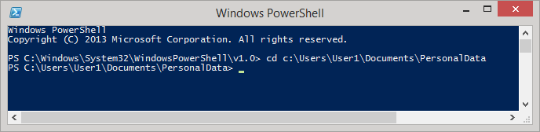

* + 1. Using the scripting commands available in PowerShell, you will search for strings of numbers in these formats: Social Security number XXX XX XXXX and credit card number YYYY YYYY YYYY YYYY.
    2. To search for a string of numbers that may represent a Social Security number, copy and paste the following command into the PowerShell prompt and press **Enter**:

Get-ChildItem -rec -exclude *.exe,*.dll | select-string "[0-9]{3}[-| ][0-9]{2}[-| ][0-9]{4}"

To paste the command, right-click the Powershell title bar and select **Edit > Paste**.

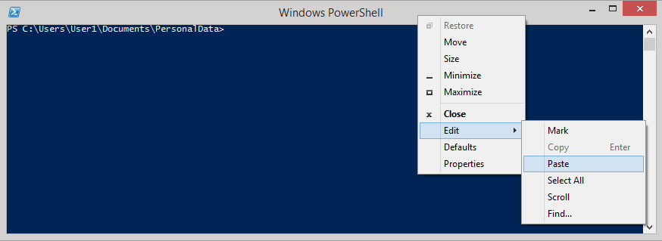

* + 1. The result from the command is displayed below.

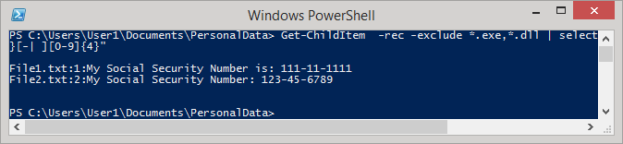

The command allows you to find items that match a defined pattern, such as the pattern for Social Security numbers. The command also excludes files with certain extensions, like .exe and .dll. The results display the text files that contain the defined pattern.

* + 1. To search for credit card numbers with the pattern of 4 groups of 4 numbers (YYYY YYYY YYYY YYYY), copy and paste the following command in the PowerShell prompt:

Get-ChildItem -rec -exclude *.exe,*.dll | select-string "[0-9]{4}[-| ][0-9]{4}[-| ][0-9]{4}[-| ][0-9]{4}"

* + 1. What are the results? Which files contain credit card information?

**Answer:**

Yes, I followed the above command and got the information in file1.txt, file2.tx and file3.txt

* + 1. If you are using Linux or Mac OS, the **grep** command can accomplish the same results.

For social security number: **grep '[0-9]\{3\}[-\ ][0-9]\{2\}[-\ ][0-9]\{4\}' \***

For credit card numbers: **grep '[0-9]\{4\}[-\ ][0-9]\{4\}[-\ ][0-9]\{4\}[-\ ][0-9]\{4\}' \***

1. Reflection

What other personal data do you store on your devices?

**Answer:**

There is a lot of personal data stored in my device. ranging from ordinary data to confidential data, such as personal photos, account passwords, financial transaction information, work, education, family and others.